**Title:** The contribution of violence to life uncertainty on a global scale

**Authors:**

*José Manuel Aburto. Interdisciplinary Center on Population Dynamics at University of Southern Denmark, Odense 5000, Denmark, and Max Planck Institute for Demographic Research, Rostock 18057, Germany.

Tim Riffe. Max Planck Institute for Demographic Research, Rostock 18057, Germany.

Vanessa di Lego. Wittgenstein Centre (IIASA, VID/ÖAW, WU), Vienna Institute of Demography / Austrian Academy of Sciences, Vienna, Austria.

Orsola Torrisi. London School of Economics, London, UK.

*Corresponding author.

**Abstract [150]:**

**Main text [3500]:**

Being unable to control the unfolding of the future is a state of uncertainty that has puzzled humans for centuries.1 Any individual making plans must, somehow, consider that he/she does not know the day when death will happen.2 *When will I die?* Is, therefore, a crucial question that shapes individuals’ decisions and their future. Most research on uncertain lifetimes, or lifespan inequality, has focused on how this unpredictability affects individual consumption and distribution of wealth.3-7 While, more recently, research on how social determinants, such as socioeconomic status, education or income, affect life span uncertainty has found that socially disadvantaged groups tend to experience higher uncertainty about their eventual death.8-13 In contexts of high violence, greater uncertainty in life suggests ineffectiveness of policies to protect individuals and implies a failure of social protection through which violence is spread in a population.14 Our article, therefore, highlights the role of violent environments on lifetime uncertainty.

Globally, lifetime uncertainty varies considerably between countries.15-21 Greater uncertainty usually corresponds to those countries with lower life expectancy.19-21 Over time, major decreases in lifespan inequality came about from reducing premature mortality since the 18th century. Particularly from saving lives at infancy, and decreasing infectious diseases and maternal mortality.22 More recently, reduced cancer mortality has helped to make length of lives more equal in developed countries.22,23 However, detailed knowledge is lacking about whether and how violence makes lifetimes uncertain: a fundamental state of vulnerability. Studies on how violence affects the quality of life often rely on subjective measures.24 Fear of crime, for example, depends on how individuals perceive their environment and, therefore, might lead to a mismatch between the real uncertainty and how it is perceived.25 For instance, females are more likely to report significant levels of vulnerability, while experiencing lower levels of victimization in periods when violence is inreasing.26 Certainly, this has an immediate effect on quality of life,27 causing higher levels of paranoia, anxiety and other mental health issues for individuals,28 while promoting segregation at the population level.26,29 Therefore, a fuller comprehension of the burden of violence on lifespan uncertainty holds potential insights for the consequences it poses on individuals and societies, their behavior in violent environments, and the future of longevity.

Here we unify lifetime uncertainty with violence and pose four questions aimed at filling this knowledge gap: How uncertain lifetimes are in the most dangerous countries in the world, compared with peaceful nations, for males compared with females, and what is the contribution of violent deaths to the observed differences? To answer these questions, we use mortality data from 163 nations from the Global Burden of Disease Study (GBD) by sex (3072 life tables),30 and information on levels of violence from the Global Peace Index for the period 2008-2017.

**Lifetime uncertainty and violence around the globe**

The level of violence in a country is determined by the Global Peace Index (GPI).31 This index ranks the peacefulness of 163 (99.7% of the global population) countries based on three domains: 1) Ongoing domestic and international conflict, 2) societal safety and security, and 3) militarization. It is constructed with 23 indicators of violence, such as number and duration of internal conflicts, level of perceived criminality, and homicide rates.31 Europe has consistently been the most peaceful region in the world over the last decade. By 2017, the most peaceful nations were Iceland, New Zealand, Portugal, Austria and Denmark. While the Middle East and North Africa (MENA) are in the other side of the spectrum as the most violent regions,31 and Latin America with highest homicide rates in the world (Figure 1A).32 Syria, Afghanistan, Iraq, South Sudan and Yemen were the most dangerous countries. These countries have in common the type of conflict [Orsola, a couple of sentences]. From Latin America, Colombia, Venezuela and Mexico were the countries with the highest levels of violence in the region. Venezuela and Mexico have undergone an unprecedented rise in homicides in the last decade due to political conflict and the war on drugs, respectively.14,32,33 While Colombia has historically been a country with high homicide rates, even though homicides have declined since 1996.32

Lifetime uncertainty can be measured with a summary indicator of how similar ages at death are. Multiple indicators exist for this purpose,34 such as the standard deviation or the Gini coefficient of the age-at-death distribution. We chose the standard deviation conditioned to surviving at age 10 to determine how spread ages at death are. The high correlation between these indices suggests that our results would not change significantly by using another index.16,34 In Syria, Iraq, El Salvador, South Africa and Venezuela, lifetime uncertainty is extraordinarily high for males and females (Figure 1B). This set of countries also share the highest levels of violence. Syria is the most dangerous country in the world and has been for the past five years, while El Salvador has presently the second highest homicide rate. In contrast, the Netherlands, Switzerland, Italy, Sweden and Norway are remarkably successful in reducing lifetime uncertainty. [Orsola please expand a bit here]

**Figure 1 Global level of violence and lifetime uncertainty for males in 2017**

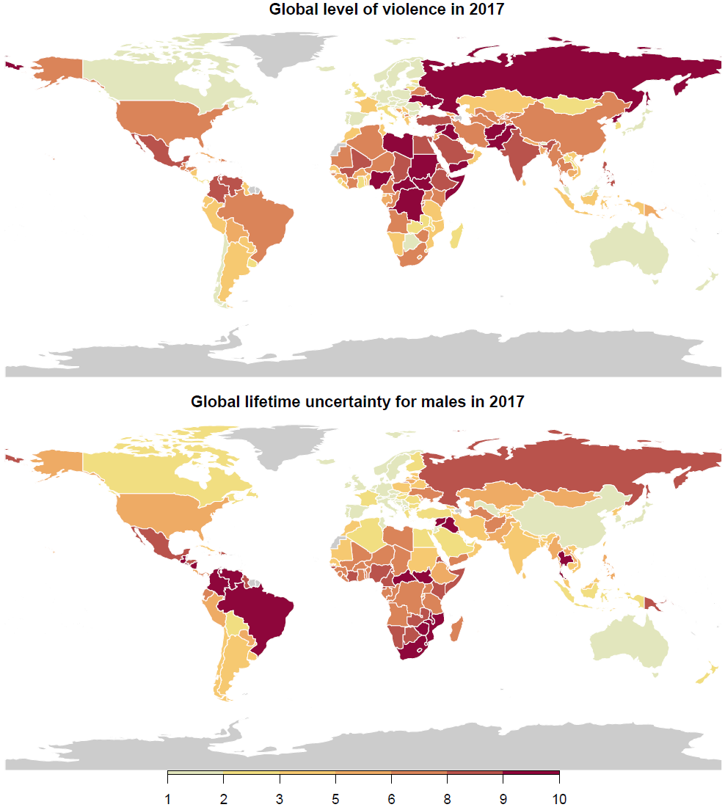

Peaceful nations all enjoy low lifetime uncertainty (Figure 2). The most violent countries tend to have higher lifetime uncertainty. Between 2008 and 2017, males and females living in the most dangerous countries showed a positive association with experiencing higher uncertainty in lifetime (correlation between GPI and life uncertainty is 0.51 and 0.44 for males and females, respectively). Moreover, the strong relationship between uncertainty about life and life expectancy suggests that those countries with high levels of violence experience lower levels of life expectancy than the peaceful nations.16 Indeed, males in Syria and Afghanistan had a life expectancy at age 10 of 57.5 and 57.5 years, respectively, while males aged 10 in Iceland and New Zealand had a expected life spans of 70 years, a gap of almost 14 years. This is important because life uncertainty is a measure of how the length of life varies and GPI measures the level of violence in a country. In principle, the two indicators could be unrelated to each other: A peaceful country could suffer high lifetime uncertainty, while a violent country might display lower mortality and uncertainty in life, and in some cases, this happens, as Israel. However, even though the set of countries with the highest life uncertainty could be completely different from the set of countries with the highest levels of violence, but it turns out that they overlap.

For females, lifetime uncertainty is lower than for males. This advantage, however, is less associated with the levels of violence (correlation of 0.44). We hypothesize that this difference results from higher mortality at young and working ages for males. This is usually referred to as the ‘young-mortality’ hump and it is an important explanatory factor of sex differences in mortality.35 For example, war related deaths are five times higher for men than for women, and homicide rates in Latin America are 10 times higher for men than for women.36 This highlights the importance of premature mortality on lifetime uncertainty in contexts of high violence.

**Figure 2 The relationship between lifetime uncertainty and the level of violence in a country by sex between 2008 and 2017.**

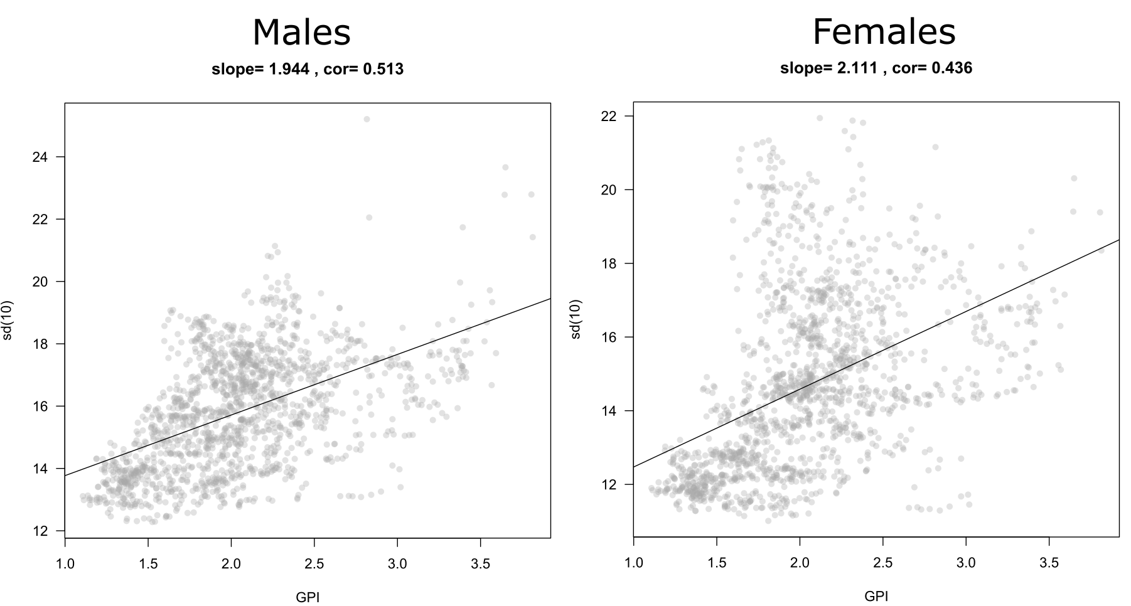

**Contribution of violent deaths to life uncertainty**

To test our hypothesis of the young mortality hump, we compared the 25 countries with the highest levels of violence in 2017 with the set of countries that ranked in the top-10 most peaceful nations in the period 2008-2017. This robust peaceful region includes Iceland, New Zealand, Austria, Portugal and Denmark, among others. Syria, Afghanistan, South Sudan, Iraq and Somalia, on the other hand, showed the least peaceful levels in 2017. This strategy allowed us to identify the ages that drive the difference in lifetime uncertainty between the countries with violent environments and the peaceful region. Additionally, we were able to analyse how much homicides, war-related, and other violent causes of death make more uncertain lifetimes relative to the peaceful region. These results, however, represent a lower bound as violent deaths are often underestimated and underreported, specially in countries with high violence. For example, in Mexico and Venezuela, the lack of data has made difficult for researcher to estimate the current level of homicides due to misclassification, underreported murders, and the increasing number of missing individuals.37

[Orsola describe decomposition results: ages and causes of death]

The countries with the lowest levels of lifespan uncertainty succeeded not only because of a general lower level of mortality at all ages, but also because their levels of deaths due to war or interpersonal violence are almost inexistent (x and y per 100,000 for males and females, respectively [Tim?]). The impact of violence, through war and interpersonal deaths, on how life is unpredictable in countries with high violence is overwhelmingly concentrated in young ages.

[Describe some countries and regions on this]

**Perspectives**

These findings make clear

* Tensions, conflicts, and crises that emerged in the past decade remain unresolved, especially in the Middle East, resulting in this gradual, sustained fall in peacefulness.
* The increase and high levels of homicide in Latin America.
* The relationship with life expectancy
* Differences between males and females
* The hump hypothesis
* Subjective survival probabilities and fear to crime.

**Acknowledgements:**

**Author contributions:** JMA, VdL, TR originated the idea and initiated this collaboration.

**Competing interests:** Non-declared.

**Methods & Data [3000]**

**Data.** We used mortality estimates for 163 countries from the Global Burden of Disease Study.30 GBD is an observational epidemiological study widely used to analyze trends in mortality and morbidity from major diseases, injuries and risk factors in a global perspective. These data are provided in 5-year age intervals with the highest interval concentrating deaths above age 85. We focus on three main causes of death related to violence Table 1 for code of the International Classification of Diseases [ICD10]): 1) homicide, 2) other violence (mostly war, state, and terrorist), and 3) all other causes.

To measure the levels of violence (or peacefulness) we use the Global Peace Index (GPI). GPI has been systematically calculated in the period that we study 2008-2017.31 It ranks the 163 countries according to the level of peacefulness. It is based on 23 qualitative and quantitative indicators that measure the state of peace using three domains: the level of societal safety and security, the extent of ongoing domestic and international conflict, and the degree of militarization. It is the most comprehensive index at a global scale and, therefore, a primary source of this study. The R-code to get the data is available at [URL].

**Demographic methods.** To more accurately measure the age-at-death distributions for each country we ungrouped the 5-year age intervals to single ages and distributed the deaths above age 85 with the penalized composite model assuming that deaths follow a Poisson distribution and calculated age-specific mortality rates.38 We constructed life tables for each country, sex, and year following standard demographic techniques.39 From these, lifespan uncertainty conditional on surviving to age 10 were calculated.

To disentangle the effect of violent deaths we calculated life expectancy and lifespan uncertainty in absence of these following the cause-deleted life table methodology.39 Additionally, we decomposed the difference in lifespan uncertainty between violent countries and RPR using the linear integral model for decomposition.40 All procedures were done using the R software,41 and are fully reproducible from the public repository [URL].

**Life span uncertainty indicator.** Several indices, highly correlated, to measure lifespan uncertainty exist.34,42 We chose the standard deviation of longevity conditional on surviving to age 10. This indicator has the advantages of being widely used as dispersion indicator in statistics, easy to interpret, decomposable into age- and cause-specific components, and is expressed in years. In life table notation the standard deviation ($σ$) is given by

$$σ=\sqrt{\int_{10}^{ω}{{(x-e_{10})}^{2}f\left(x\right)\text{d}x}}. (1)$$

Where $f\left(x\right),e_{10}$ and $ω$ denote the age-at-death density function, life expectancy at age 10, and the open-aged interval (110+ in our case), respectively. We condition to age 10 to capture the onset of violent deaths, which [x%, Tim?] occur over this age, and because infant mortality conceals mortality dynamics of adult ages.43

**Robustness check with life disparity.** All figures were replicated using “life disparity” or average life lost. This indicator has been used in several lifespan inequality studies, including one focusing on homicide mortality. The indices differ in their sensitivity to changes in mortality and in properties and is measured in years, allowing a direct comparison with the standard deviation. While some variations in the levels of lifetime uncertainty were observed, the main results and conclusions of our study are supported.

**Robustness check conditioning on surviving to different ages.**

**Selection of violent countries and construction of the robust peaceful region (RPR).** We focus on the worst and best performers of GPI to compare the burden of violence on lifespan uncertainty. The “Best Performers” category includes all countries that ranked in the top ten over the period 2008-2017: Australia, Austria, Belgium, Canada, Switzerland, Czech Republic, Denmark, Finland, Ireland, Iceland, Japan, Norway, New Zealand, Portugal, Singapore, Slovenia and Sweden. The “Most Violent” category includes the 25 worst performers countries that scored a low or very low level of GPI in 2017. [Lets create a table with both the peaceful, violent and life uncertainty levels, gpi] To have more robust comparisons of lifetime uncertainty between violent countries and a peaceful environment, we constructed a “Robust Peaceful Region” based on the best performers of GPI. It was determined by the weighted mean of age-specific death rates by sex of the Best Performers. The weights were constructed according to the instances each country appeared in the top ten.

**References [50]**

1 Reith, G. Uncertain times: the notion of ‘risk’and the development of modernity. *Time & Society* **13**, 383-402 (2004).

2 Yaari, M. E. Uncertain lifetime, life insurance, and the theory of the consumer. *The Review of Economic Studies* **32**, 137-150 (1965).

3 Abel, A. B. Precautionary saving and accidental bequests. *The American Economic Review* **75**, 777-791 (1985).

4 Eckstein, Z., Eichenbaum, M. & Peled, D. Uncertain lifetimes and the welfare enhancing properties of annuity markets and social security. *Journal of Public Economics* **26**, 303-326 (1985).

5 Barro, R. J. & Friedman, J. W. On uncertain lifetimes. *Journal of Political Economy* **85**, 843-849 (1977).

6 Caliendo, F. N., Gorry, A. & Slavov, S. Survival Ambiguity and Welfare. (National Bureau of Economic Research, 2017).

7 Chang, F.-R. Uncertain lifetimes, retirement and economic welfare. *Economica*, 215-232 (1991).

8 Firebaugh, G., Acciai, F., Noah, A. J., Prather, C. & Nau, C. Why lifespans are more variable among blacks than among whites in the United States. *Demography* **51**, 2025-2045 (2014).

9 Lariscy, J. T., Nau, C., Firebaugh, G. & Hummer, R. A. Hispanic-White differences in lifespan variability in the United States. *Demography* **53**, 215-239 (2016).

10 Sasson, I. Trends in life expectancy and lifespan variation by educational attainment: United States, 1990–2010. *Demography* **53**, 269-293 (2016).

11 van Raalte, A. A. *et al.* More variation in lifespan in lower educated groups: evidence from 10 European countries. *International Journal of Epidemiology*, dyr146 (2011).

12 van Raalte, A. A., Martikainen, P. & Myrskylä, M. Lifespan variation by occupational class: compression or stagnation over time? *Demography* **51**, 73-95 (2014).

13 van Raalte, A. A., Sasson, I. & Martikainen, P. The case for monitoring life-span inequality. *Science* **362**, 1002-1004 (2018).

14 Aburto, J. M. & Beltrán-Sánchez, H. Upsurge of Homicides and Its Impact on Life Expectancy and Life Span Inequality in Mexico, 2005–2015. *American journal of public health*, e1-e7 (2019).

15 Aburto, J. M. & van Raalte, A. Lifespan dispersion in times of life expectancy fluctuation: the case of Central and Eastern Europe. *Demography* **55**, 2071-2096 (2018).

16 Colchero, F. *et al.* The emergence of longevous populations. *Proceedings of the National Academy of Sciences* **113**, E7681-E7690 (2016).

17 Németh, L. Life expectancy versus lifespan inequality: a smudge or a clear relationship? *PloS one* **12**, e0185702 (2017).

18 Shkolnikov, V. M., Andreev, E. M., Zhang, Z., Oeppen, J. & Vaupel, J. W. Losses of expected lifetime in the United States and other developed countries: methods and empirical analyses. *Demography* **48**, 211-239 (2011).

19 Smits, J. & Monden, C. Length of life inequality around the globe. *Social Science & Medicine* **68**, 1114-1123 (2009).

20 Vaupel, J. W., Zhang, Z. & van Raalte, A. A. Life expectancy and disparity: an international comparison of life table data. *BMJ open* **1**, e000128 (2011).

21 Wilmoth, J. R. & Horiuchi, S. Rectangularization revisited: Variability of age at death within human populations. *Demography* **36**, 475-495 (1999).

22 Seligman, B., Greenberg, G. & Tuljapurkar, S. Equity and length of lifespan are not the same. *Proceedings of the National Academy of Sciences* **113**, 8420-8423 (2016).

23 Aburto, J. M., Wensink, M., van Raalte, A. & Lindahl-Jacobsen, R. Potential gains in life expectancy by reducing inequality of lifespans in Denmark: an international comparison and cause-of-death analysis. *BMC public health* **18**, 831 (2018).

24 Curiel, R. P. & Bishop, S. R. Fear of crime: the impact of different distributions of victimisation. *Palgrave Communications* **4**, 46 (2018).

25 Skogan, W. G. The impact of victimization on fear. *Crime & Delinquency* **33**, 135-154 (1987).

26 Canudas-Romo, V., Aburto, J. M., García-Guerrero, V. M. & Beltrán-Sánchez, H. Mexico's epidemic of violence and its public health significance on average length of life. *Journal of epidemiology and community health* **71**, 188-193 (2017).

27 Jackson, J. & Gray, E. Functional fear and public insecurities about crime. *The British Journal of Criminology* **50**, 1-22 (2009).

28 Ruijsbroek, A., Droomers, M., Groenewegen, P. P., Hardyns, W. & Stronks, K. Social safety, self-rated general health and physical activity: changes in area crime, area safety feelings and the role of social cohesion. *Health & place* **31**, 39-45 (2015).

29 Carro, D., Valera, S. & Vidal, T. Perceived insecurity in the public space: Personal, social and environmental variables. *Quality & Quantity* **44**, 303-314 (2010).

30 Institute for Health Metrics and Evaluation (IHME). *GBD Compare. Seattle, WA: IHME, University of Washington*, < <http://vizhub.healthdata.org/gbd-compare>> (2019).

31 Institute for Economics & Peace. *Global Peace Index 2018: Measuring Peace in a Complex World, Sydney*, <<http://visionofhumanity.org/reports>> (2019).

32 United Nations Office on Drugs Crime. *Global study on homicide 2013: trends, contexts, data*. (UNODC, 2013).

33 Aburto, J. M., Beltrán-Sánchez, H., García-Guerrero, V. M. & Canudas-Romo, V. Homicides in Mexico reversed life expectancy gains for men and slowed them for women, 2000–10. *Health Affairs* **35**, 88-95 (2016).

34 van Raalte, A. A. & Caswell, H. Perturbation analysis of indices of lifespan variability. *Demography* **50**, 1615-1640 (2013).

35 Remund, A., Camarda, C. G. & Riffe, T. A cause-of-death decomposition of young adult excess mortality. *Demography* **55**, 957-978 (2018).

36 Briceño-León, R., Villaveces, A. & Concha-Eastman, A. Understanding the uneven distribution of the incidence of homicide in Latin America. *International Journal of Epidemiology* **37**, 751-757 (2008).

37 Aburto, J. M., Riffe, T. & Canudas-Romo, V. Trends in avoidable mortality over the life course in Mexico, 1990–2015: a cross-sectional demographic analysis. *BMJ open* **8**, e022350 (2018).

38 Rizzi, S. *et al.* How to estimate mortality trends from grouped vital statistics. *International journal of epidemiology* (2018).

39 Preston, S. H., Heuveline, P. & Guillot, M. *Demography. Measuring and Modeling Population Processes*. (Blackwell, 2001).

40 Horiuchi, S., Wilmoth, J. R. & Pletcher, S. D. A decomposition method based on a model of continuous change. *Demography* **45**, 785-801 (2008).

41 Team, R. C. (2014).

42 Wrycza, T. F., Missov, T. I. & Baudisch, A. Quantifying the shape of aging. *PloS one* **10**, e0119163 (2015).

43 Edwards, R. D. & Tuljapurkar, S. Inequality in life spans and a new perspective on mortality convergence across industrialized countries. *Population and Development Review* **31**, 645-674 (2005).